Redevelopment Sites in the South Bronx between 2005 to 2009

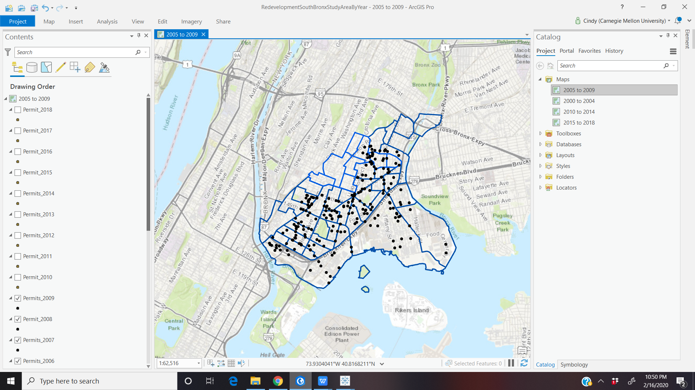

Redevelopment Sites in the South Bronx between 2010 to 2014

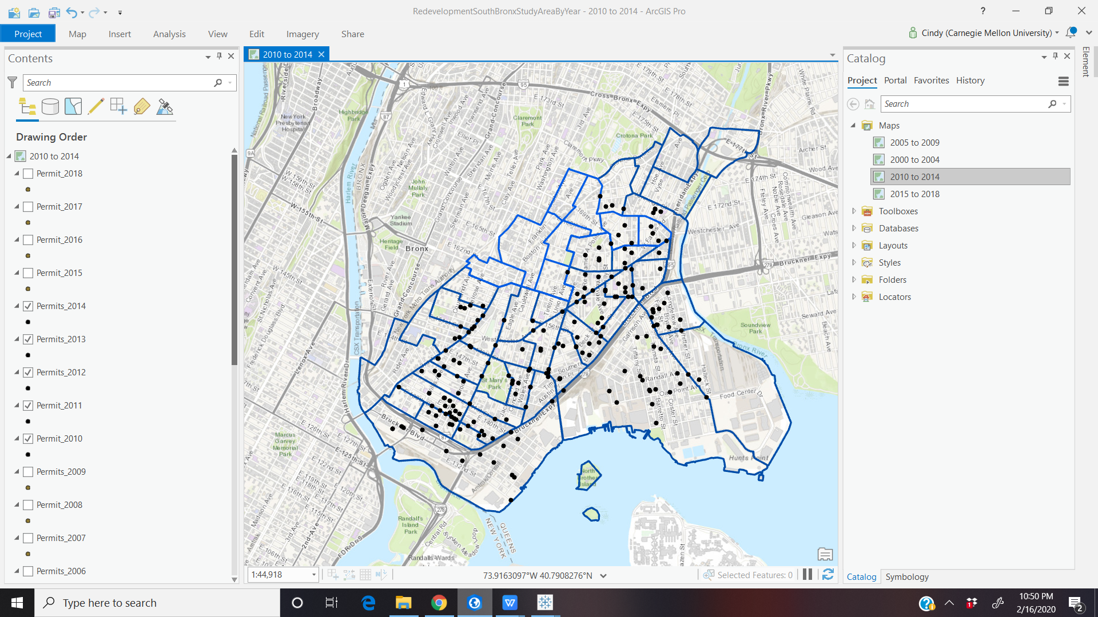

Redevelopment Sites in the South Bronx between 2015 to 2018

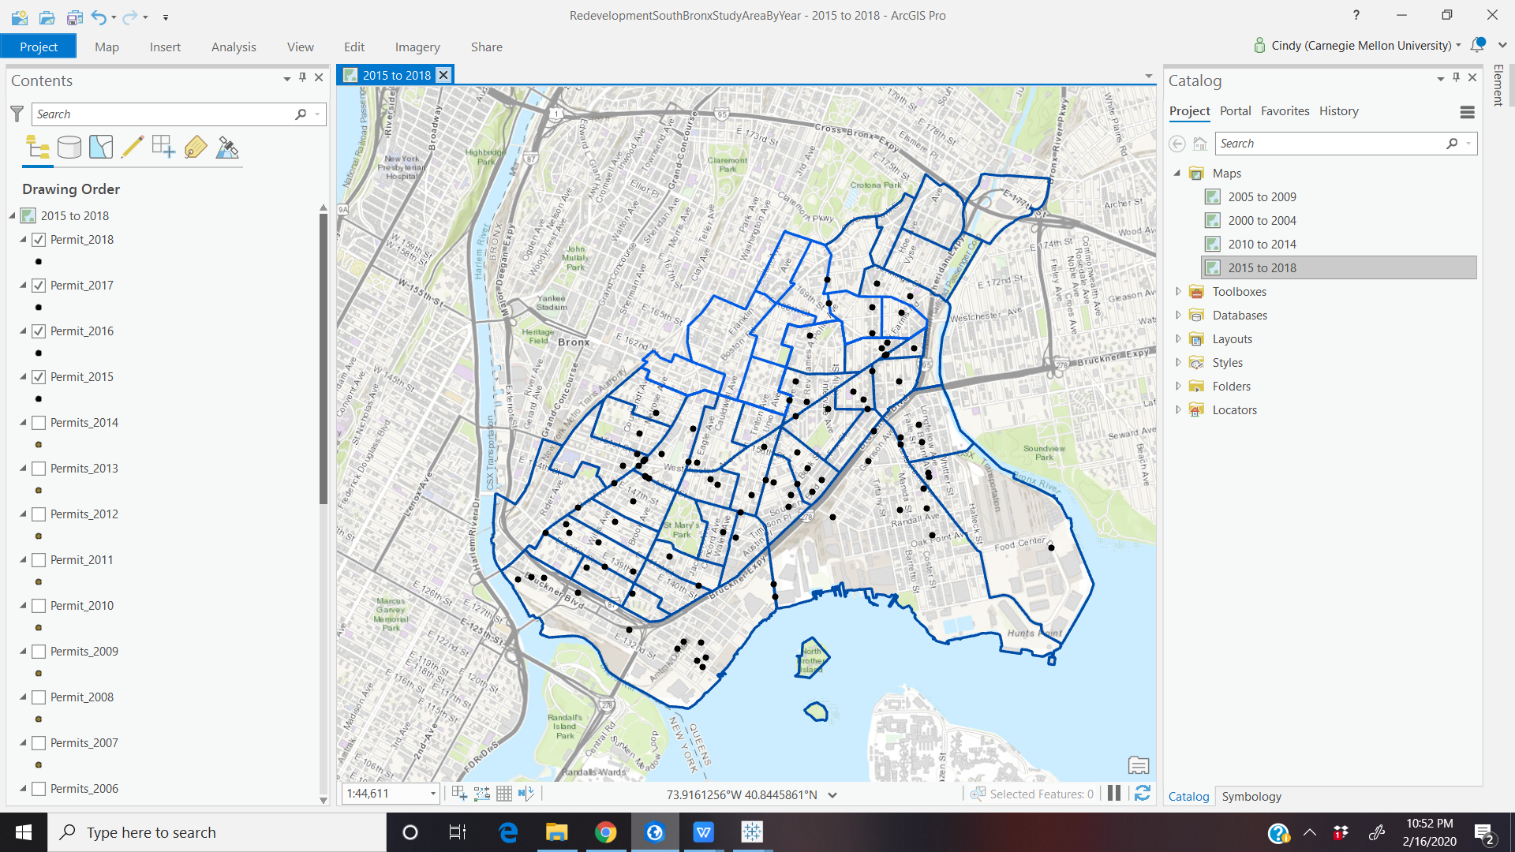

Tableau- Median Income by Age

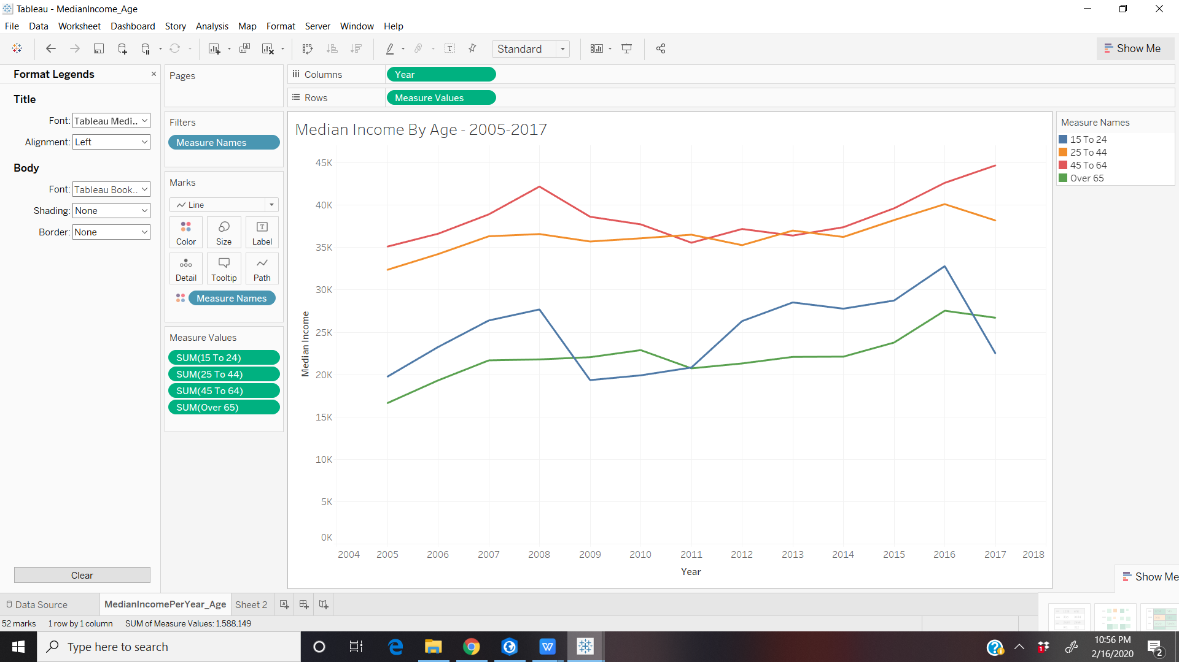

Median Income by Race

